Eg : String_Eg113
// go through the code

Eg: String_Eg114
// go through the code

Eg: String_Eg115
// go through the code

Eg: String_Eg116
// go through the code

Eg: String_Eg117
//go through the code

Eg: String_Eg118
// go through the code

Eg: String_Eg119
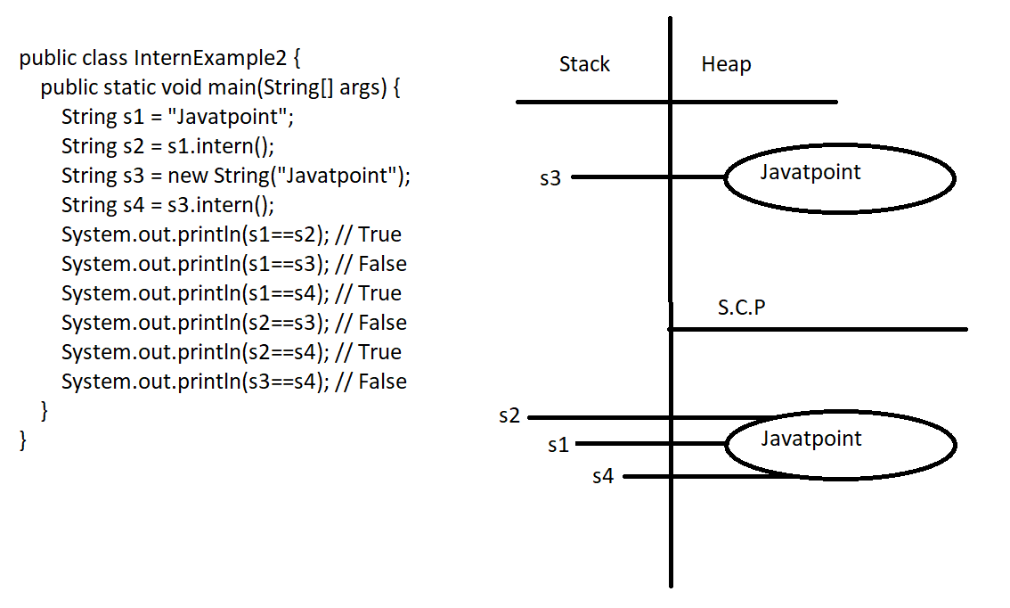
Eg: String_Eg120
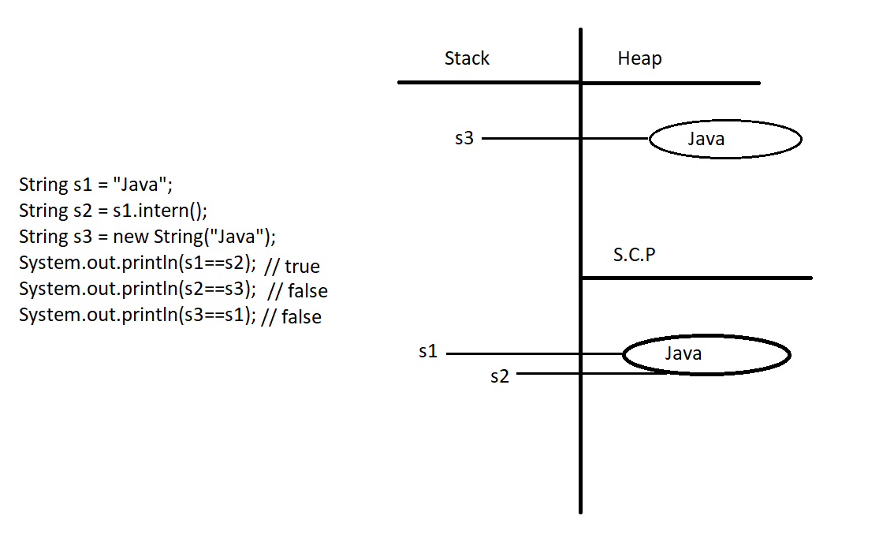

Eg: String_Eg121
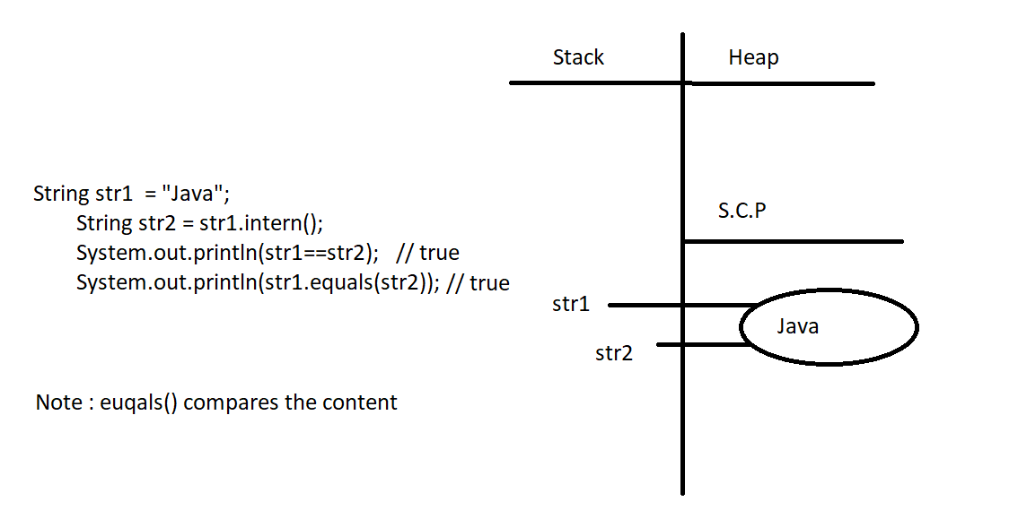

Eg: String_Eg122
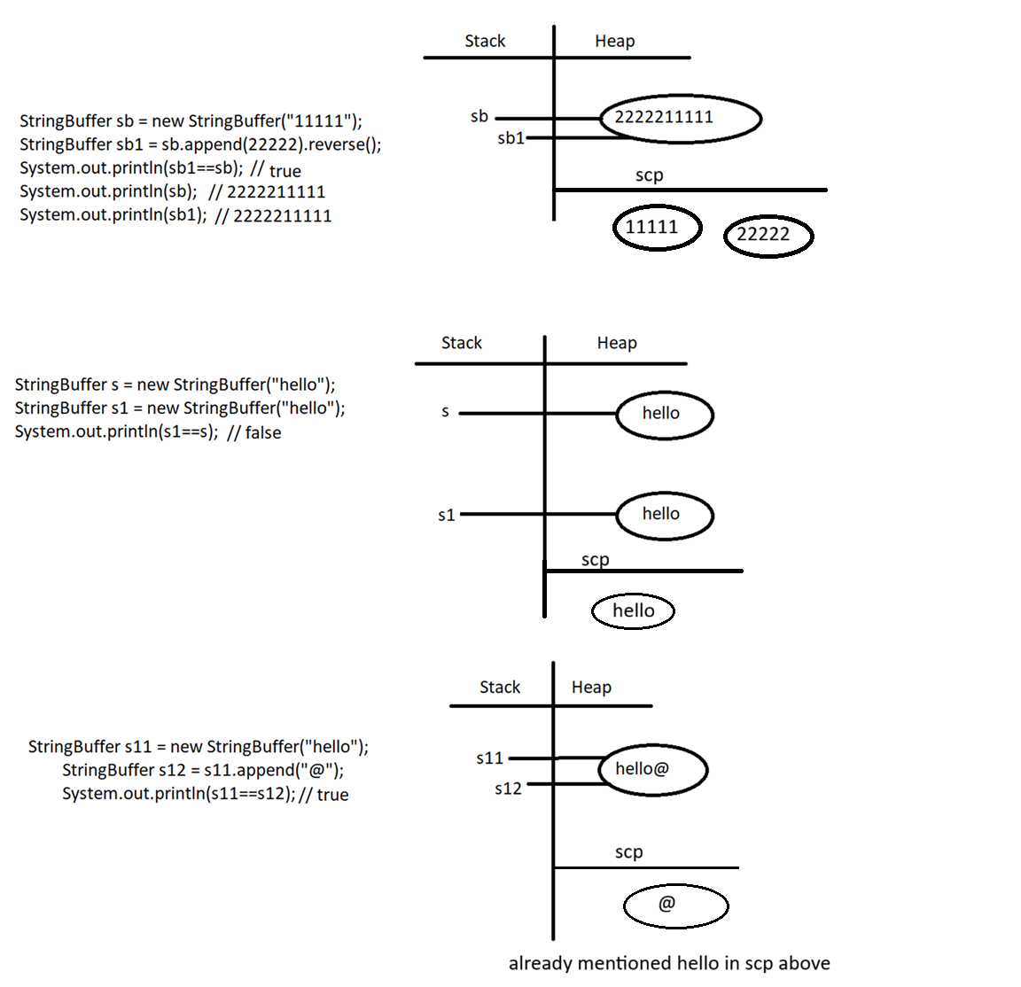

Eg: String_Eg123
// go through the code

Eg: String_Eg124
// go through the code

Eg: String_Eg125
// go through the code

Eg: String_Eg126
// go through the code

Eg: String_Eg127
// go through the code

Eg: String_Eg128
// go through the code

Eg: String_Eg129
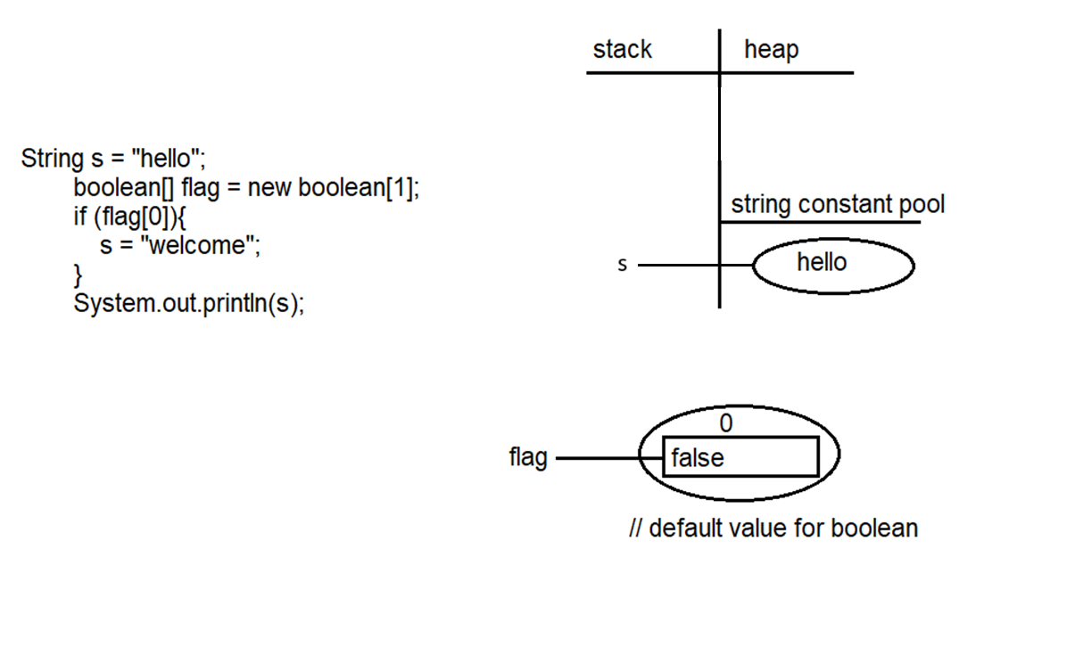

Eg: String_Eg130
// go through the code

Eg: String_Eg131
//go through the code

Eg: String_Eg132
// go through the code
Eg: String_Eg133
// go through the code

Eg: String_Eg134
// go through the code

Eg: String_Eg135
🔑 Important exam points
- If first operand is String, + becomes String concatenation
- null is converted to "null" when concatenated with String
- Primitive values are converted to String automatically
- Evaluation happens left to right
🧠 One-line memory trick
String first → everything becomes String

Eg: String_Eg136
//go through the code.

Eg: String_Eg137
🔑 Important exam points
- indexOf(char) → returns first occurrence index
- indexOf(String) → returns starting index of substring
- Index always starts from 0
- If not found → returns -1
- Arithmetic addition is performed on returned index values
🧠 One-line memory trick
Substring index = starting character index

Eg: String_Eg138
🔑 Important exam points
- String.join() is a static method
- Delimiter is placed between elements, not at the end
- Works with String array or var-args
- Returns a new String object
🧠 One-line memory trick
join(delimiter, array) → glue array elements together

Eg: String_Eg139
// go through the code

Eg: String_Eg140
🔹 Key rule (this never changes)
Default values are assigned to VARIABLES, not to objects themselves
Now let’s apply this rule to your case.

🔹 Case 1: Boolean[] b = new Boolean[2];
Boolean[] b = new Boolean[2];
What is created here?
- One array object of size 2 is created
- Each element of the array is a reference variable of type Boolean
⚠️ Important:
- Boolean is a wrapper class
- Wrapper class = object reference
- Default value of any object reference is null
So internally memory looks like this:
b ───▶ [ null , null ]
👉 Array object is created
👉 But Boolean objects inside are NOT created
👉 Hence elements are null

🔹 Why “object created” doesn’t mean values exist?
Because this line:
new Boolean[2]
👉 creates ONLY the array object
👉 it does NOT create Boolean objects for each index
To create Boolean objects, you must do:
b[0] = true;
b[1] = false;
Now memory becomes:
b ───▶ [ Boolean(true), Boolean(false) ]

🔹 Case 2: boolean[] arr = new boolean[2];
boolean[] arr = new boolean[2];
Here:
- boolean is a primitive
- Default value of primitive boolean = false
So memory:
arr ───▶ [ false , false ]

🔹 Why difference?
Type | Stored in array | Default value
boolean[] | primitive values | false
Boolean[] | object references | null

🔹 Case 3: Instance variable vs Local variable
Boolean b; // instance variable → default = null
boolean x; // instance variable → default = false
But:
void m() {
Boolean b; // ❌ NO default value
boolean x; // ❌ NO default value
}
Local variables never get default values.

🧠 One-line memory trick (VERY IMPORTANT)
Array is created → elements get default value of their TYPE
Not “object created → values exist”.

✅ Final clarity sentence (use this in exams/interviews):
Creating an array of wrapper type creates only the array, not the wrapper objects, hence elements are null.

Eg: String_Eg141
// go through the code

Eg: String_Eg142
// go through the code

Eg: String_Eg143
Note: Wrapper classes and String class is immutable (changes will not be made in the same object instead new object will be created with the new change)
StringBuilder, StringBuffer are mutable ( changes will be made in the same object) .

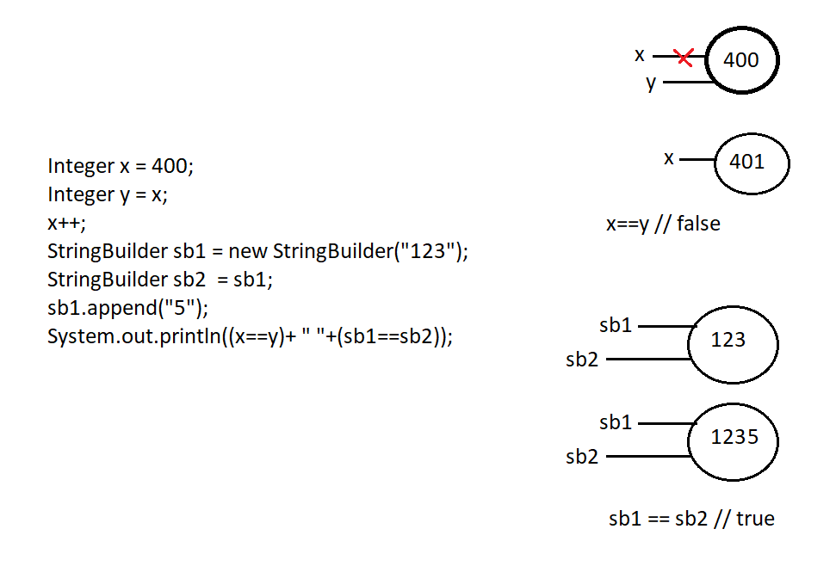

Important exam takeaways
- Integer is immutable
- x++ creates a new Integer object
- StringBuilder is mutable
- Changes affect the same object
- == compares references, not values
🧠 One-line memory trick
Immutable → new object | Mutable → same object
all Java wrapper classes are immutable like String.
That includes:
- Integer
- Byte
- Short
- Long
- Float
- Double
- Character
- Boolean

🔹 What does immutable mean here?
Immutable means:
- Once the object is created, its value cannot be changed
- Any “update” creates a NEW object
- If the old object has no reference, it becomes eligible for GC

🔹 Example: Integer
Integer x = 10;
x = x + 1;
What really happens:
- x → Integer(10)
- x + 1 → unboxing → 10 + 1
- New Integer(11) object is created
- x now points to Integer(11)
- Old Integer(10) → eligible for GC (if no other reference)
✔ Exactly like String

🔹 Example: Boolean
Boolean b = true;
b = false;
- true and false are fixed objects
- b now points to a different Boolean object
- Original object remains unchanged

🔹 Example: Character
Character c = 'A';
c++;
- 'A' is unboxed → incremented → 'B'
- New Character('B') is created
- Old object unchanged

🔹 Compare with mutable classes ❌
Class | Mutable?
String | ❌ No
Integer | ❌ No
Boolean | ❌ No
Character | ❌ No
StringBuilder | ✅ Yes
StringBuffer | ✅ Yes
ArrayList | ✅ Yes

🔹 Important nuance (VERY IMPORTANT FOR INTERVIEWS)
Wrapper classes are immutable, but some values are cached.
Example:
Integer a = 100;
Integer b = 100;
System.out.println(a == b); // true (cached)
But:
Integer a = 400;
Integer b = 400;
System.out.println(a == b); // false (not cached)
Caching range:
- Integer: -128 to 127
- Byte, Short, Character, Boolean: cached
⚠️ Caching does NOT mean mutability
Objects are still immutable.

🧠 One-line golden rule (write this)
All wrapper classes are immutable; reassignment creates a new object and old one becomes GC-eligible if unreferenced.

✅ Final summary
- ✔ All wrapper classes are immutable
- ✔ Any “update” → new object
- ✔ Old object → GC eligible if no reference
- ✔ Similar to String
- ⚠️ Caching affects ==, not mutability
If you want next:

Eg: String_Eg144
// go through the code

Eg: String_Eg145
// go through the code

Eg: String_Eg146
// go through the code

Eg: String_Eg147
// go through the code

